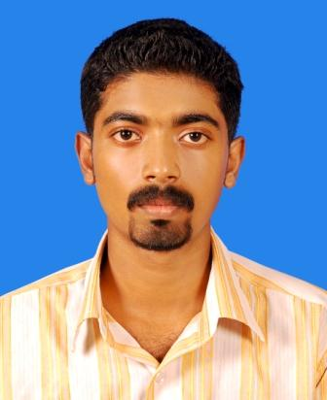
Neethu Mariam Varghese
NJALIPLACKAL HOUSE
EZHUMATTOOR P.O.
PATHANAMTHITTA 689586, Kerala.
Telephone: (Mob.) +91-9400594052 / (Res.) +91-9446171200
Email: neethumv1712@gmail.com

OBJECTIVE

“Dedicating myself for the growth of company along with the growth of technology and market. To utilize my maximum potential towards the technical challenges and upgrade myself”.

EDUCATIONAL PROFILE

Degree/  Examination | Board/  University | Name of school/  College | Year  of  passing | Subjects  Combination | Marks  (%)
B.Tech | Calicut University | Calicut University Institute of Engineering and Technology, Thenhipalam. | 2012 | Information  Technology | 65%(aggregate up to 7th semester)
Higher  Secondary  Examination | Kerala State  Board | St.Threresa’s  Bethany Convent  Higher Secondary  School,  Chengaroor. | 2008 | Science (PCM+  Biology) | 75%
Secondary  Examination | Kerala State  Board | St.Threresa’s  Bethany Convent  Higher Secondary  School,Chengaroor. | 2006 | Science, Social  Science, Maths,  Languages | 78%

SKILL SETS
Operating Systems | Windows XP/7, Linux(Fedora Core)
Programming Languages  Application Package  Database | JAVA, J2ME, C, C++, C# .Net  MS Office Suite  SQL Server
Achievements and Activities

- Completed certification course on C and Java from ‘G-Tec computer education’
- Participated in dance, mimicry, monoact and singing competitions at college and inter-college and district levels and won prizes
- Volunteered and acted as Single Point of Contact in the Result and Jury committee of ’Diksha’ the South Indian Technical and Cultural fest hosted by Calicut University Institute of Engineering & Technology, Thenhipalam, Kerala.
- Participated in literal and sports activities and won prizes.

Projects AND SEMINAR
- As a part of course curriculum (BTech) did a project in NEXEGEN, Kozhikode to develop a software “Mobile File Manager”, to transfer files from mobile phone to computer and we can retrieve the files whenever needed through remote monitoring.
- Conducted a seminar on “Skinput”, an application uses a series of sensors to track where a user taps on his arm. Tapping on different parts of your arm creates different kinds of vibrations depending on the amount and shape of bones, tendons and muscle in that specific area. Skinput sensors can track those vibrations using an armband and discern where the user tapped.
- As a part of course curriculum (BTech) done a project in ARION INFOTECH, Kakkanchery to develop a project on “Truth Discovery”, to retrieve the relevant information by comparing the data’s from existing search engines.

MERITS
- Skills in JAVA, J2ME, C, C++, MASM, C# .Net
- Consistently good academic record.
- Has the motivation to take responsibility, and be a productive team member.
- Possesses excellent Interpersonal and Communication skills.

Personal Profile

Name : Neethu Mariam Varghese
Father’s Name : John Varghese
Mother’s Name : Lalitha John Varghese
Gender : Female
Date of birth : 17th Dec 1990
Nationality : Indian
Languages known : English and Malayalam
Hobbies and Interests : Playing badminton, Watching TV,
Listening to music.

Declaration:
I hereby declare that the information furnished above is true to the best of my knowledge.

Neethu Mariam Varghese
Place: Ezhumattoor
Date: 06-06-2012

